

Data Science Club hackathon
Group 8:The Standard Deviants
Group Members: Ovayo Jack: 202101500
Thuthukani Nhlengethwa: 202316164
Bulumko Teta:202402810
Aphelele Gwebityala: 202430482
Thuto Matlolokwe: 202302808
Introduction
Financial fraud imposes direct monetary losses on banks and mobile-money operators and erodes customer trust, yet fraudulent transactions typically represent a tiny fraction of all activity. This creates a severe class-imbalance problem: a model that simply predicts “not fraud” for every transaction would be over 99.8% accurate while catching no fraud at all. The objective of this project was therefore not raw accuracy, but building a system that reliably separates the rare fraudulent transactions from legitimate ones while keeping the operational cost of false alarms manageable.
The dataset used is a synthetic log of mobile-money transactions modelled on real transaction behaviour from an African mobile-money service.
The full analysis pipeline followed six stages: exploratory data analysis (EDA), feature engineering, multicollinearity correction (via Variance Inflation Factor screening and Principal Component Analysis), Mutual-Information-based feature selection, supervised model training and comparison, and finally a lightweight, interpretable rule-based flagging engine intended as a business-facing companion to the statistical models.
Dataset Overview
The dataset contains 636,262 transactions, of which only 849 (0.133%) are labelled fraudulent; a severe class imbalance typical of real-world fraud data. Each record includes the transaction type, amount, and the sender's and receiver's account balances before and after the transaction, along with a simulated time step.

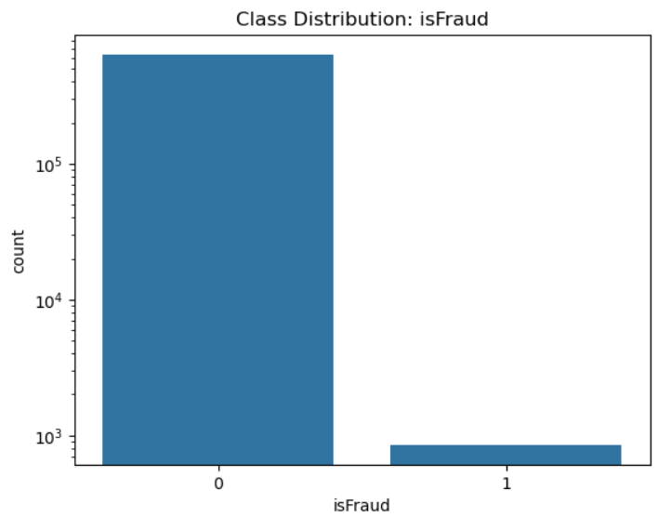
Figure 1: Class distribution of fraudulent and non-fraudulent transactions
Exploratory Data Analysis
- Fraud is confined to two transaction types
Fraud occurs exclusively within TRANSFER and CASH_OUT transactions; CASH_IN, DEBIT, and PAYMENT transactions contain zero fraud cases in this dataset. This is a strong, low-noise signal that transaction type should be a core model feature.
Transaction Type | Fraud Count | Total Count | Fraud Rate
TRANSFER | 432 | 53,270 | 0.811%
CASH_OUT | 417 | 223,846 | 0.186%
CASH_IN | 0 | 139,684 | 0.000%
DEBIT | 0 | 4,147 | 0.000%
PAYMENT | 0 | 215,315 | 0.000%

- Fraudulent transactions are larger, on average
Fraudulent transactions average approximately 1.50 million compared to roughly 178,000 for legitimate transactions, though both distributions are heavily right skewed with substantial overlap amount alone is informative but not sufficient to separate the classes cleanly.
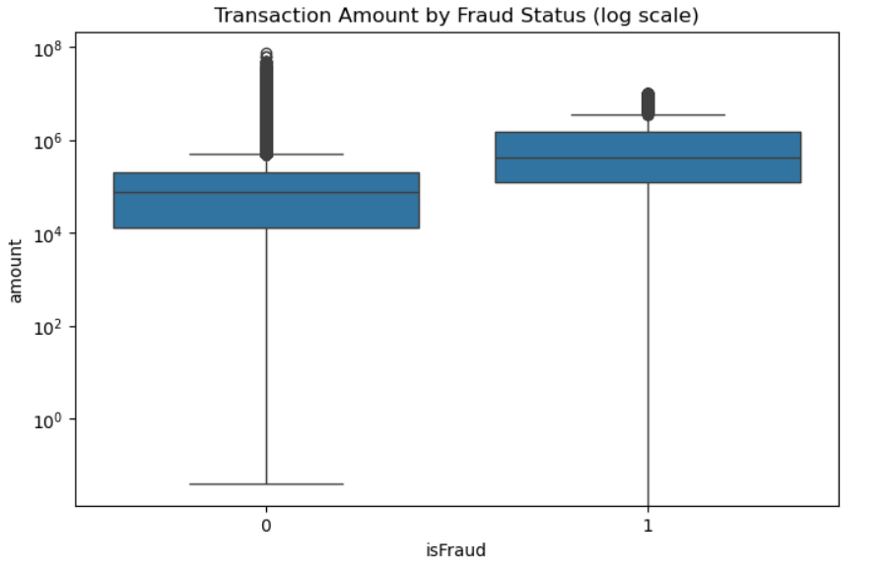
Figure 2 : Transaction amount by fraud status (log status).
- Balance-error features reveal an arithmetic tell
Two engineered features — errorBalanceOrig and errorBalanceDest — measure whether the change in an account's balance matches the transaction amount exactly. For fraudulent transactions, errorBalanceOrig has a median of exactly 0, meaning the sender's balance update is arithmetically perfect, whereas legitimate transactions frequently show nonzero discrepancies (e.g. due to fees or partial holds). This mismatch turned out to be one of the strongest predictive signals in the dataset.
- Time-of-day patterns
Splitting the simulated step counter into hour_of_day (step % 24) showed that fraud rates spike in the early-morning hours (roughly 2 a.m.–6 a.m.), reaching over 20% of transactions in the sparsest hours, compared to well under 0.1% during business hours. Transaction volume is far lower overnight, so these rates are noisier, but the pattern was consistent enough to retain hour_of_day as a feature.
Feature Engineering and Multicollinearity Treatment
- Balance-Error and Zero-Balance Features
Two engineered features check whether each transaction's before/after balances are arithmetically consistent: errorBalanceOrig = newbalanceOrig + amount − oldbalanceOrg, and errorBalanceDest = oldbalanceDest + amount − newbalanceDest. Fraudulent transactions showed a median errorBalanceOrig of exactly zero, while legitimate transactions frequently carried a non-zero error term — a strong but suspiciously clean synthetic-data artefact that was flagged as a caution for how well the model may generalise to real-world data with noisier bookkeeping.
Three binary flags were also engineered: origZeroBefore, destZeroBefore, and destZeroAfter. Counter-intuitively, fraud rarely originates from an already-empty account (only 0.24% of fraud cases have origZeroBefore = 1, since an empty account cannot be drained), whereas fraud disproportionately sends funds to zero-balance ‘mule’ accounts — destZeroBefore is true for 66.2% of fraud cases versus 33.8% of legitimate ones.
- Multicollinearity: VIF and PCA
A Variance Inflation Factor (VIF) check on the raw balance columns confirmed severe redundancy: newbalanceOrig and oldbalanceOrg had VIFs of 410.0 and 409.1 respectively, and newbalanceDest / oldbalanceDest had VIFs of 74.4 and 64.6. VIF values well above the conventional threshold of 10 indicate that these variables carry almost identical information, which distorts coefficient estimates in linear models such as logistic regression.
While a VIF-of-10 rule of thumb is common practice, it should be treated as a guideline rather than an absolute cut-off, since the acceptable threshold depends on sample size and the standard errors of the coefficients involved (O’Brien, 2007). Given the sample size here (>600,000 rows) and the near-perfect duplication observed, dropping the redundant old-balance columns in favour of the new-balance columns was a safe and well-justified simplification.
amount and errorBalanceOrig were also highly correlated (r ≈ 0.97), since amount is algebraically embedded in the error-balance formula. Rather than simply dropping one, Principal Component Analysis (PCA) was applied to the standardised pair; the first principal component captured 98.5% of their shared variance and replaced both original columns (amount_errBal_PC1).
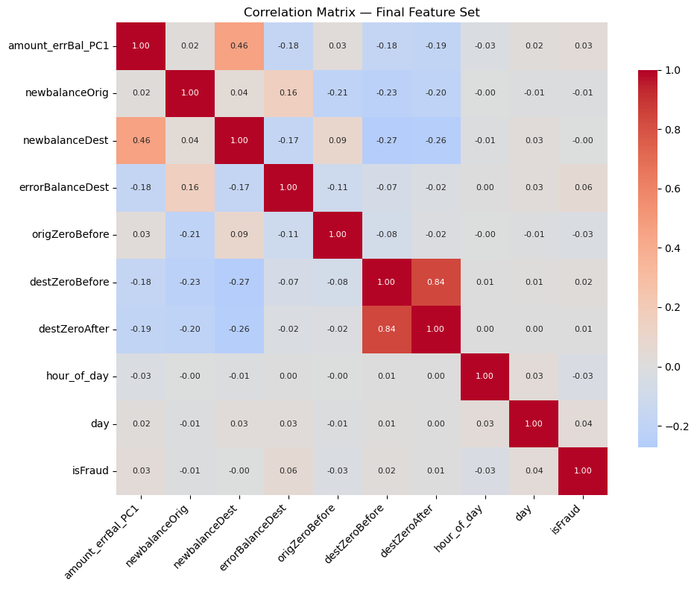
Figure 3:Correlation matrix of all numerical methods.
A VIF check on the final feature set (amount_errBal_PC1, newbalanceOrig, newbalanceDest, errorBalanceDest, the zero-balance flags, hour_of_day, and day) confirmed all VIF values fell below 3.6, well within acceptable limits.
Interestingly, every engineered feature showed only weak linear (Pearson) correlation with isFraud. This is expected: fraud in this dataset follows threshold and interaction rules (for example, errorBalanceOrig ≈ 0 together with type = TRANSFER) rather than a straight-line relationship — exactly the kind of pattern that linear correlation underestimates but tree-based models are built to capture.
- Mutual Information Feature Selection
Because correlation only captures linear relationships, Mutual Information (MI) was used as a second, non-linear screen. MI naturally captures both linear and threshold/interaction effects, and it also allowed type — one-hot encoded into four dummy columns — to be scored on equal footing with the engineered numeric features, closing a gap left by the VIF/PCA-only feature set.
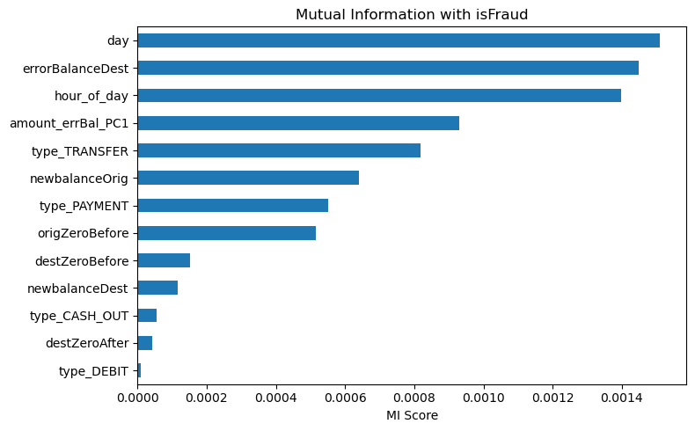
Figure 4: Mutual Information scores of candidates features with isFraud.
Modelling Methodology
- Train/Test Split and Undersampling
The data was split 80/20 into training and test sets, stratified on isFraud so that both sets preserved the same 0.13% fraud rate. Undersampling of the majority (legitimate) class was applied only to the training set, at a 1:2 fraud-to-legitimate ratio, using imbalanced-learn's RandomUnderSampler. Undersampling before the split would leak information into the test set and inflate apparent performance, so the test set was left untouched and fully imbalanced to reflect real-world conditions.
This train-then-resample ordering, and the broader rationale for treating imbalanced classification differently from balanced classification, follows established guidance in the imbalanced-learning literature (He & Garcia, 2009).
- Models Trained
Five classifiers were trained and compared, each regularised to guard against overfitting to the near-deterministic errorBalanceOrig/amount artefact identified in EDA:
- Logistic Regression (LR) — L2-regularised via LogisticRegressionCV, strength chosen by 5-fold cross-validation on scaled features.
- Bayesian Logistic Regression (BLR) — implemented in PyMC using Automatic Differentiation Variational Inference (ADVI); a tight Normal(0,1) prior on scaled coefficients acts as the regulariser.
- Decision Tree (DT) — depth and leaf-size constrained (max_depth=6, min_samples_leaf=20).
- Random Forest (RF) — max_depth=8, min_samples_leaf=10.
- XGBoost — max_depth=4 with L1 and L2 penalties (reg_alpha, reg_lambda).
XGBoost's regularised, gradient-boosted tree ensemble is designed for exactly this kind of tabular, imbalanced classification problem and has become a standard baseline across data-science competitions (Chen & Guestrin, 2016), while Random Forest provides a robust bagged-tree comparison point (Breiman, 2001). The Bayesian logistic regression, fitted with ADVI (Kucukelbir et al., 2017), gives a probabilistic counterpart to the frequentist LR with the same linear decision boundary.
Results and Model Comparison
All models were evaluated on the same untouched, imbalanced test set (127,253 transactions, 170 fraud cases) using ROC-AUC and Precision-Recall AUC (PR-AUC). PR-AUC is the more informative metric here, since ROC-AUC can look deceptively strong under extreme imbalance.
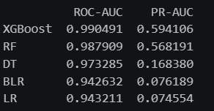
Model comparison on the held-out test set, sorted by PR-AUC. XGBoost was the strongest model overall (PR-AUC = 0.594), followed closely by Random Forest (0.568). Both tree ensembles substantially outperformed the linear models, reinforcing the earlier observation that fraud in this data follows non-linear, threshold-based patterns rather than linear ones.
- Feature Importance
Feature importance was compared across four independent methods — XGBoost gain, Random Forest impurity reduction, absolute Logistic Regression coefficients, and the earlier Mutual Information scores — normalised to a common 0–1 scale. origZeroBefore, newbalanceOrig, type_TRANSFER, and errorBalanceDest consistently ranked among the top features across methods, giving converging, multi-method evidence that these four variables carry the strongest fraud signal. Where methods disagreed (for example, day and hour_of_day ranking higher under MI and RF than under XGBoost or LR), this reflects how differently each model type captures signal: tree-based models pick up threshold and interaction effects that linear models structurally cannot represent.
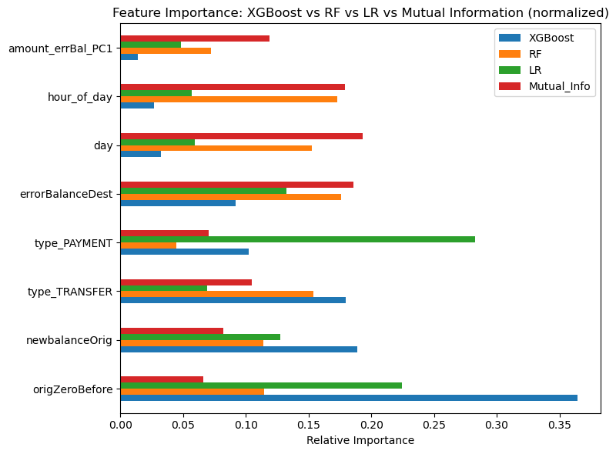
Figure 6:Normalised feature importance: XGBoost vs. Random Forest vs. Logistic Regression vs. Mutual Information.
Alongside the statistical models, a simple, fully interpretable rule engine was built as a business-facing alternative that requires no trained model and can be explained in plain language to a fraud analyst. Each transaction is scored against six rules (transaction type risk, zero error-balance, origin account drained, destination zero before/after, and a large-amount threshold of R200,000), and flagged once its rule count crosses a chosen threshold.
A threshold sweep was run on the same held-out test set used for the ML models, to keep the comparison fair. At a threshold of rule_count ≥ 2, the engine caught 100% of test-set fraud (0% FN rate) at the cost of a 69.0% false-alarm rate — flagging roughly seven in ten legitimate transactions.
- Discussion, Limitations, and Recommendations
XGBoost is the strongest candidate for production use, offering the best balance of missed fraud (8.8%) and false alarms (2.9%) of any model tested. Random Forest is a reasonable, slightly more conservative alternative. The linear models (LR and Bayesian LR) are best understood as interpretable baselines rather than deployment candidates, since fraud in this dataset is governed by threshold and interaction effects that linear decision boundaries cannot represent.
Several limitations temper how far these results should be generalised. First, the errorBalanceOrig artefact — a near-perfectly clean signal for fraud in this synthetic data — is unlikely to hold with the same sharpness in real-world bookkeeping, where legitimate transactions also carry rounding and timing noise; production performance should be re-validated on live data before deployment. Second, the classification threshold used for each model was not separately cost-optimised against the bank's actual FN:FP cost ratio; the FN/FP tables in Section 7.1 are the foundation for that follow-on step rather than a substitute for it. Third, PR-AUC and the reported rates depend on the specific 1:2 undersampling ratio chosen for training; other ratios were not swept, and doing so is a natural next step.
Recommended next steps: (1) deploy XGBoost as the primary scoring model with a threshold tuned to the bank's specific cost ratio for FN vs. FP; (2) retain the rule engine as an explainable secondary check and audit-trail layer, particularly for regulatory reporting; (3) monitor model performance over time, since fraud patterns and transaction volumes are non-stationary and the model will need periodic retraining; and (4) validate the errorBalanceOrig signal against real transaction logs before relying on it as heavily as this synthetic dataset allows.
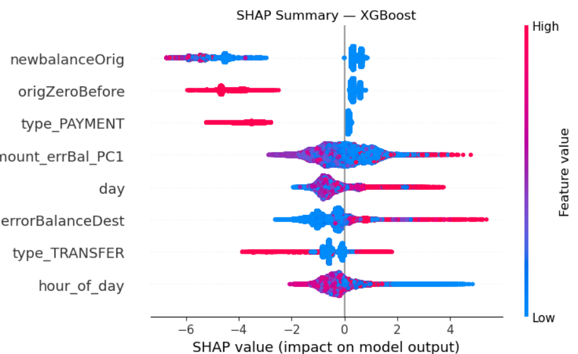
Figure 7:SHAP plot.
newbalanceOrig: blue (low resulting balance) sits left, red (high) sits slightly right → very low leftover balance after the transaction pushes toward "not fraud," here.
origZeroBefore (likely a flag: did the account start at zero balance): red (yes) clusters left → strongly pushes toward "not fraud." Blue (no) spreads right.
type_PAYMENT: red (is a payment) sits left → payments push toward "not fraud," consistent with before.
amount_errBal_PC1 (looks like a PCA-combined feature of amount + balance errors): wide spread on both sides with mixed colors → this is now a big, complex driver of the prediction, but color doesn't cleanly separate direction, since it's a composite feature.
day: mild spread, mostly clustered near zero → weak effect overall.
errorBalanceDest: blue (low) sits left, red (high) stretches right → higher destination balance errors push toward fraud.
type_TRANSFER: red (is a transfer) sits right → transfers push toward fraud, same as before.
hour_of_day: wide spread both directions, no clean color separation → still not a strong, consistent signal on its own.
- AI Usage Reflection
AI tools were used as a thinking and productivity aid, not a substitute for statistical judgement, and it's worth noting where they helped and where they needed checking.
AI assistance was most useful in three ways. First, explaining unfamiliar techniques — like why VIF values above 10 signal redundancy, or how Automatic Differentiation Variational Inference approximates a Bayesian posterior when full MCMC was too slow. Second, speeding up routine, error-prone code — confusion-matrix comparisons across five models, PR-curve plotting, and the rule-based flagging function — freeing time for decisions that mattered, like feature engineering and justifying the undersampling ratio. Third, as a sounding board for structuring the narrative — ordering EDA, multicollinearity treatment, and feature selection so each stage's motivation precedes its result.
This help had real limits. AI-suggested code was never run unexamined: VIF/PCA logic and rule-engine thresholds were checked against printed output (e.g., confirming PCA components explained 98.5% of shared variance before dropping columns, and re-deriving FN/FP formulas by hand). Suggestions about which features "should" matter were treated as hypotheses tested via Mutual Information and feature importance, since a language model has no access to this dataset's actual structure and can sound confident while wrong. Interpretive claims — like why fraud clusters in TRANSFER/CASH_OUT, or why errorBalanceOrig looks "too clean" — were grounded in printed crosstabs and summary statistics, not accepted from the AI's phrasing.
Overall, AI shortened the gap between idea and test, valuable given hackathon time constraints — but core decisions (features, imbalance handling, model choice, FN/FP tradeoffs) were made and verified against the data throughout, not delegated to the tool.
References
Breiman, L. (2001). Random forests. Machine Learning, 45(1), 5–32. https://doi.org/10.1023/A:1010933404324
Chen, T., & Guestrin, C. (2016). XGBoost: A scalable tree boosting system. In Proceedings of the 22nd ACM SIGKDD International Conference on Knowledge Discovery and Data Mining (pp. 785–794). Association for Computing Machinery. https://doi.org/10.1145/2939672.2939785
He, H., & Garcia, E. A. (2009). Learning from imbalanced data. IEEE Transactions on Knowledge and Data Engineering, 21(9), 1263–1284. https://doi.org/10.1109/TKDE.2008.239
Kucukelbir, A., Tran, D., Ranganath, R., Gelman, A., & Blei, D. M. (2017). Automatic differentiation variational inference. Journal of Machine Learning Research, 18(14), 1–45.
Lopez-Rojas, E. A., Elmir, A., & Axelsson, S. (2016). PaySim: A financial mobile money simulator for fraud detection. In Proceedings of the 28th European Modeling and Simulation Symposium (EMSS 2016) (pp. 249–255). Dime University of Genoa.
O’Brien, R. M. (2007). A caution regarding rules of thumb for variance inflation factors. Quality & Quantity, 41(5), 673–690. https://doi.org/10.1007/s11135-006-9018-6

